Curriculum Vitae
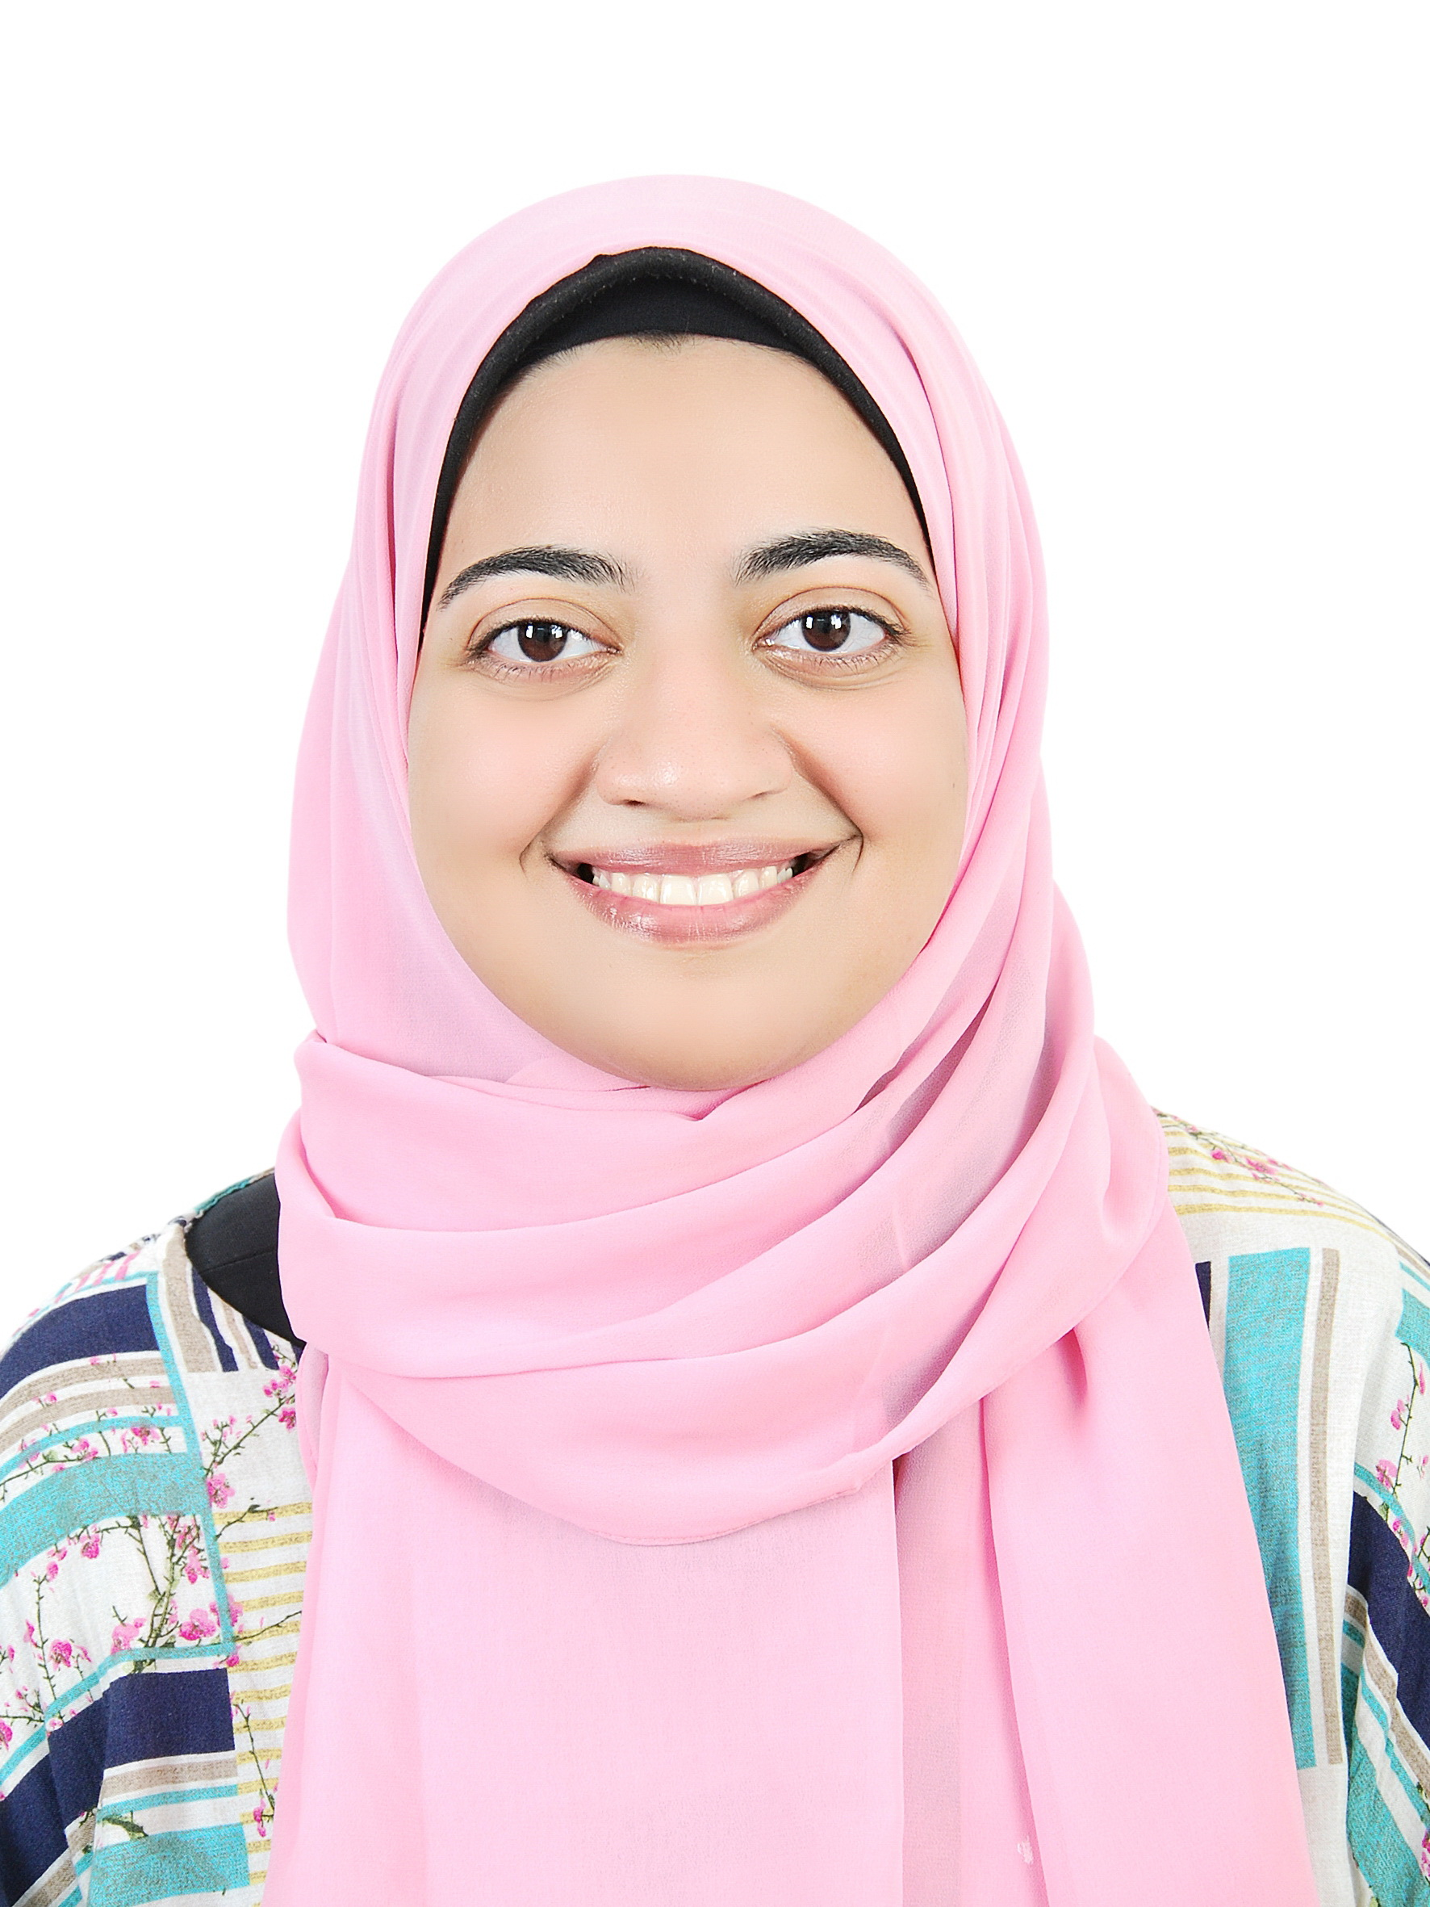
Name: Reem Yassien Abd El-Kareem
Date of Birth: August 22nd,1996.
Gender: Female.
Religion: Muslim
Nationality: Egyptian
Address: Assiut, Egypt.
Contact Address: Department of Pharmaceutics, Faculty of Pharmacy, Assiut University
E-mail: reemmhran4@gmail.com
Reem_Yassien@pharm.aun.edu.eg
Languages: English (excellent), Arabic (native language)
Academic Qualifications:
Bachelor in Pharmacy, Faculty of Pharmacy, Assiut University in 2019, and Demonstrator at Pharmaceutics Department, Faculty of Pharmacy, Assiut University.
Excellence with honor
Grade:
Demonstrator at Pharmaceutics Department Faculty of Pharmacy, Assiut University.
Computer Skills:
1- Microsoft Office.
2- Molecular Operating Environment.

